Deploying an S3 Bucket
Create a new subdirectory for this project
Create 3 Terraform configuration files

s3.tf
providers.tf
outputs.tf

Details for each are already uploaded in my GitHub Repository

Documentation
aws_s3_bucket_public_access_block | Resources | hashicorp/aws | Terraform | Terraform Registry
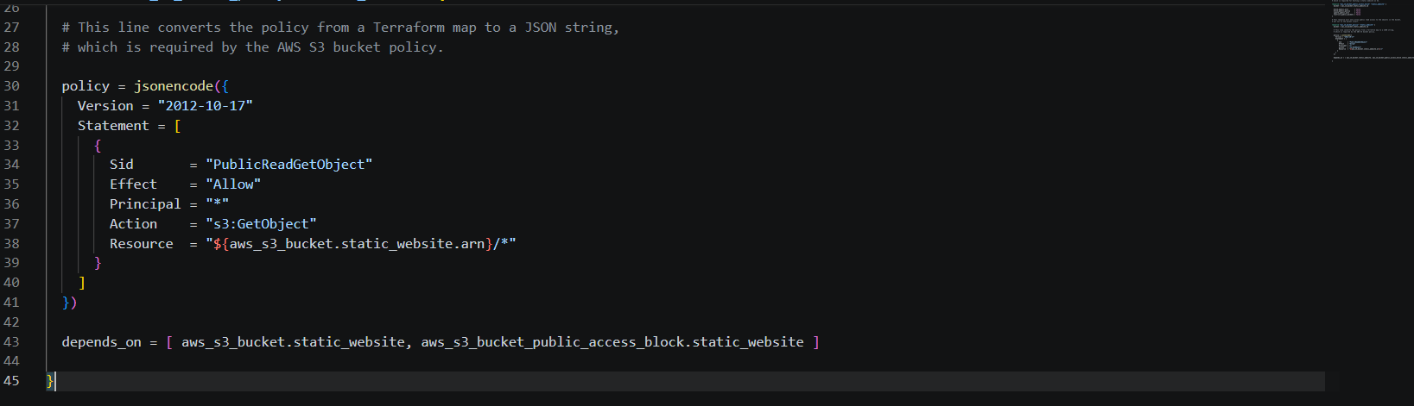

The code above converts the HCL code to json

Initialize these configuration files
terraform init

Run plan command
terraform plan

Apply the plan
terraform apply

At this stage, S3 Bucket is created but not yet configured as static S3 website

Upload the 2 html files manually via AWS console first to the static S3 bucket and configure static policy with the following entries

{
"Version": "2012-10-17",
"Statement": [
{
"Sid": "PublicReadGetObject",
"Effect": "Allow",
"Principal": "*",
"Action": "s3:GetObject",
"Resource": "arn:aws:s3:::your bucket name/*"
},
{
Go to Properties Tab and look for static website hosting section found at the very bottom of the page and click edit to enable S3 static website hosting with the following entries and hit save:

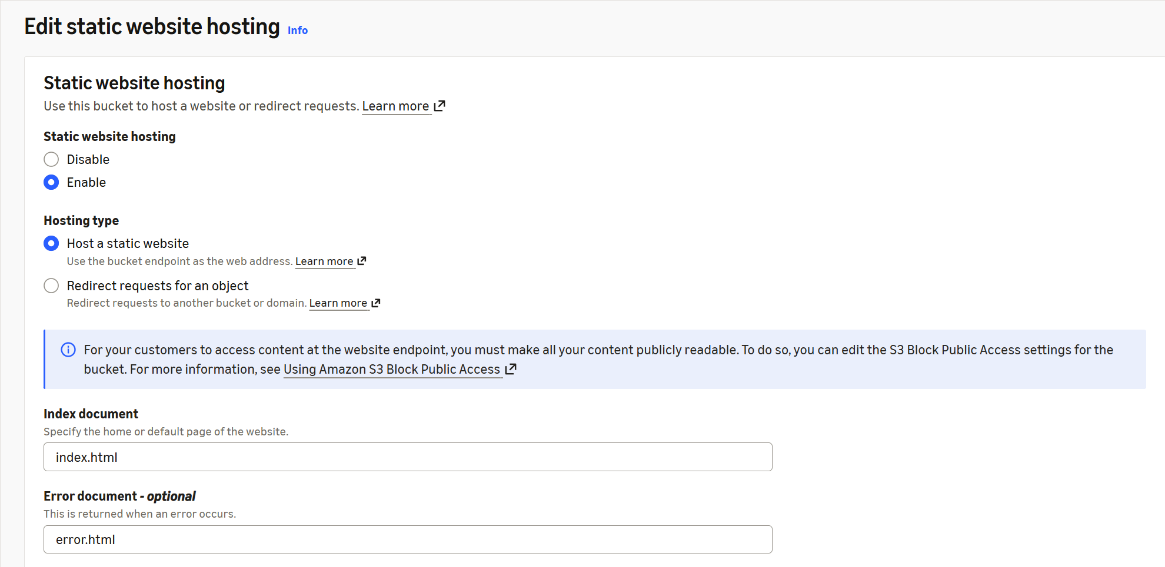

To check if the static page works, go to the properties tab of your index.html file and copy/paste the link shown in the Object URL section.

Deploying Cloudfront to secure and accelerate the loading of our static website

Create a Cloudfront Distribution
Since I am using an AWS Free Tier account, I chose the FREE Plan

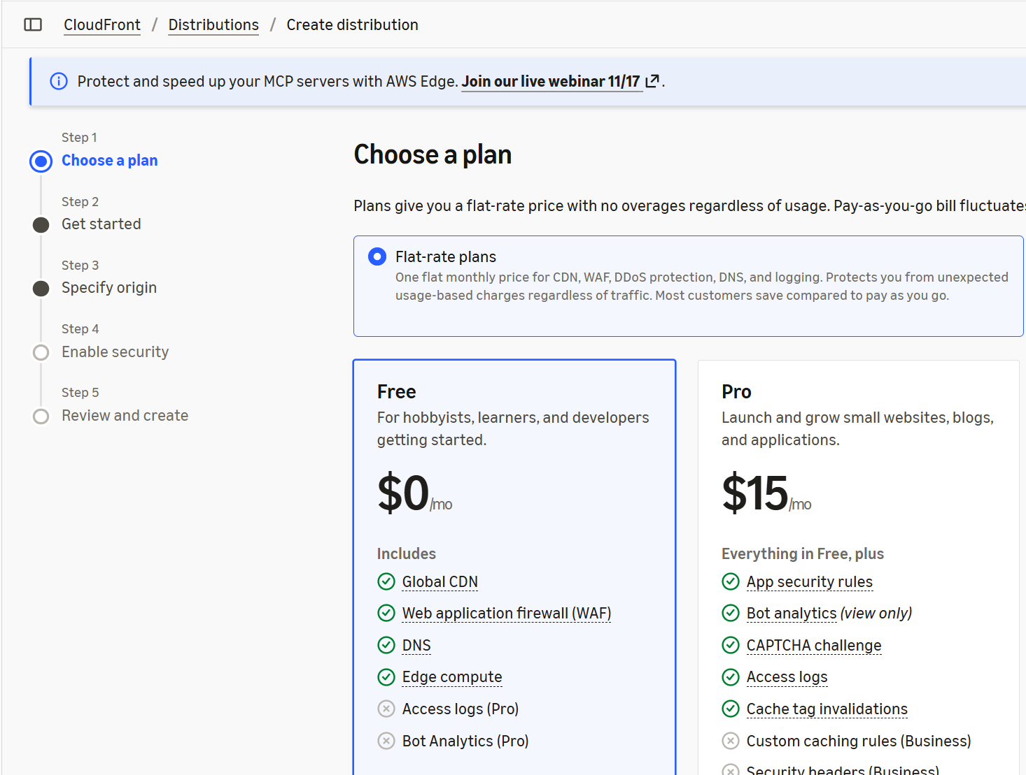
Give it a name and a description for you to know what this distribution is used for

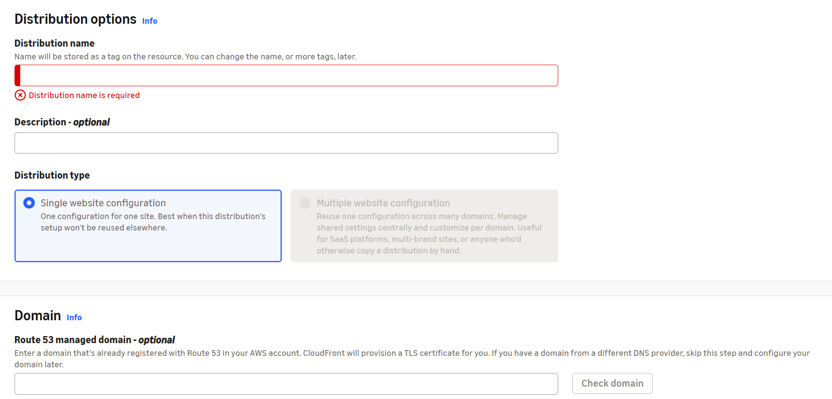

I did not use AWS Route 53 in this case but instead prefer to use GoDaddy to host my domain and DNS records. Details will be shared in the later part of this documentation.

Next step is to specify origin

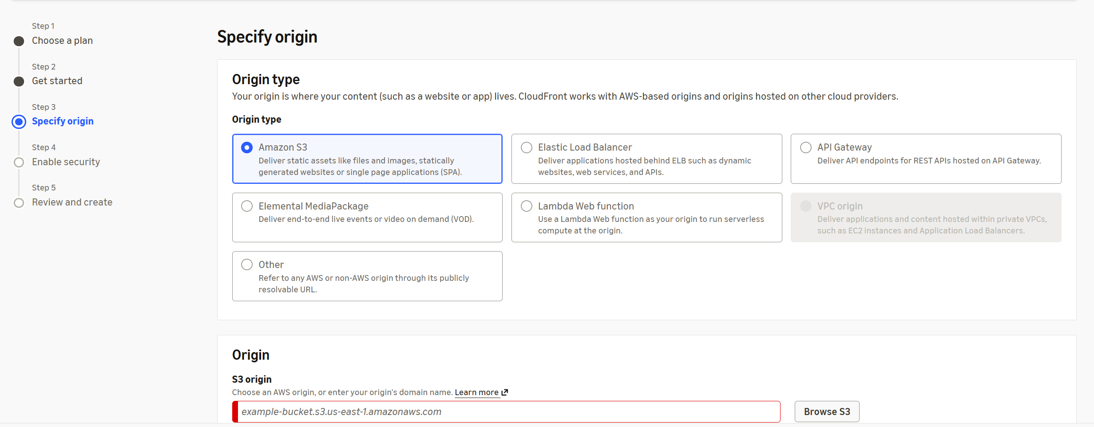

Click “Browse S3” button and select the S3 bucket created

Usually AWS will recommend you enable website endpoint - accept the recommendation

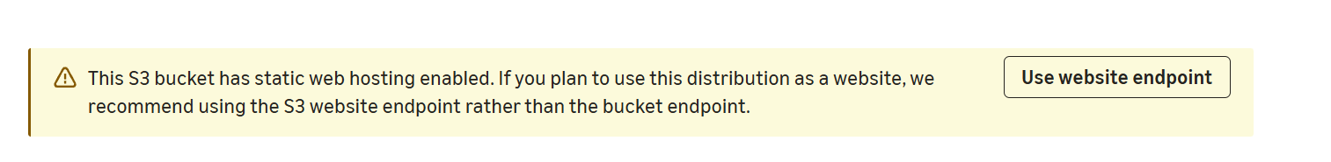
You will then see at the bottom of your s3 bucket

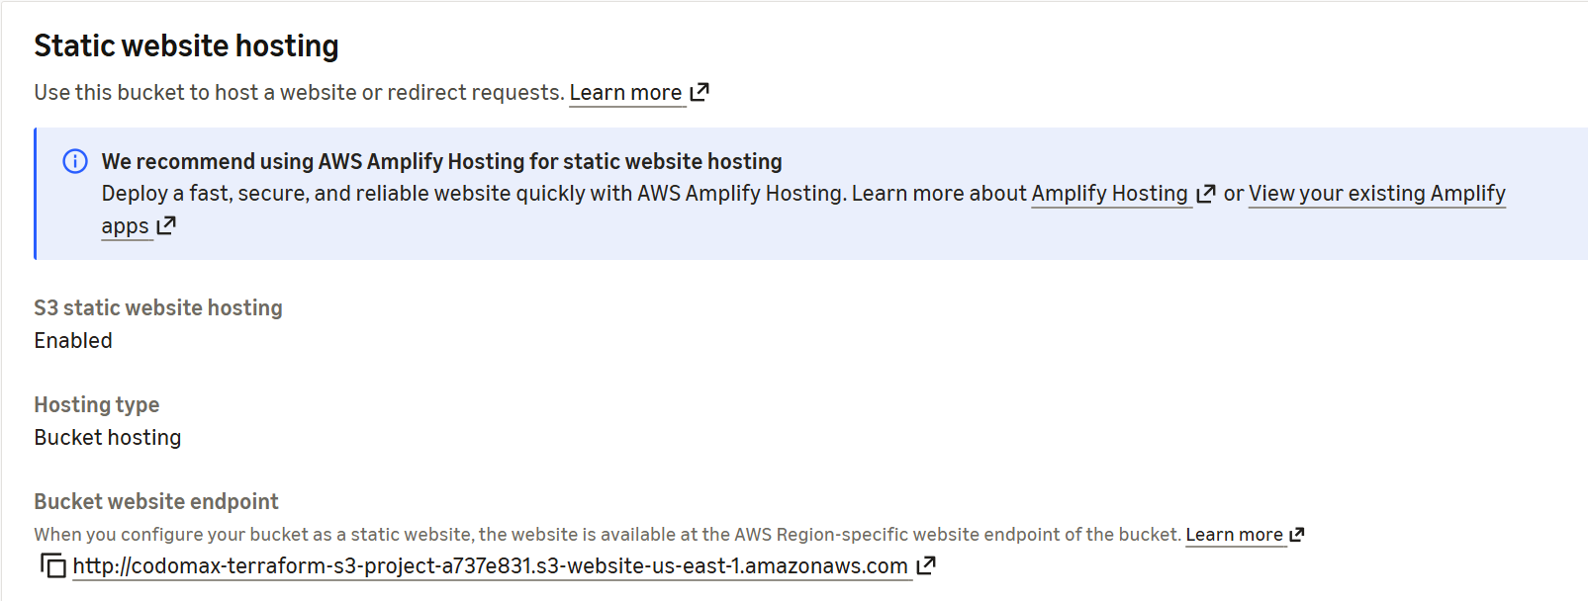

Continuation of Cloudfront setup
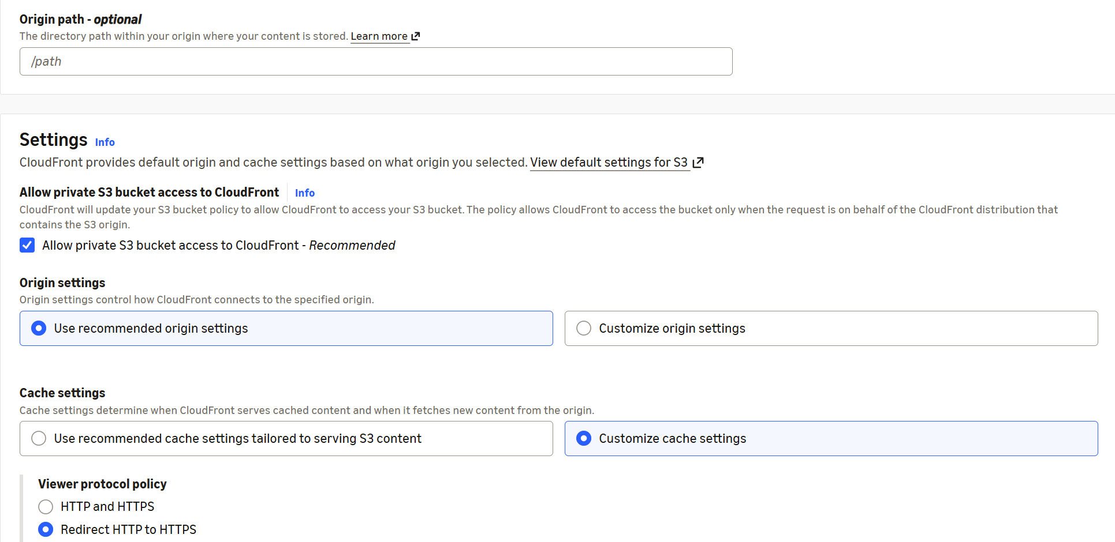

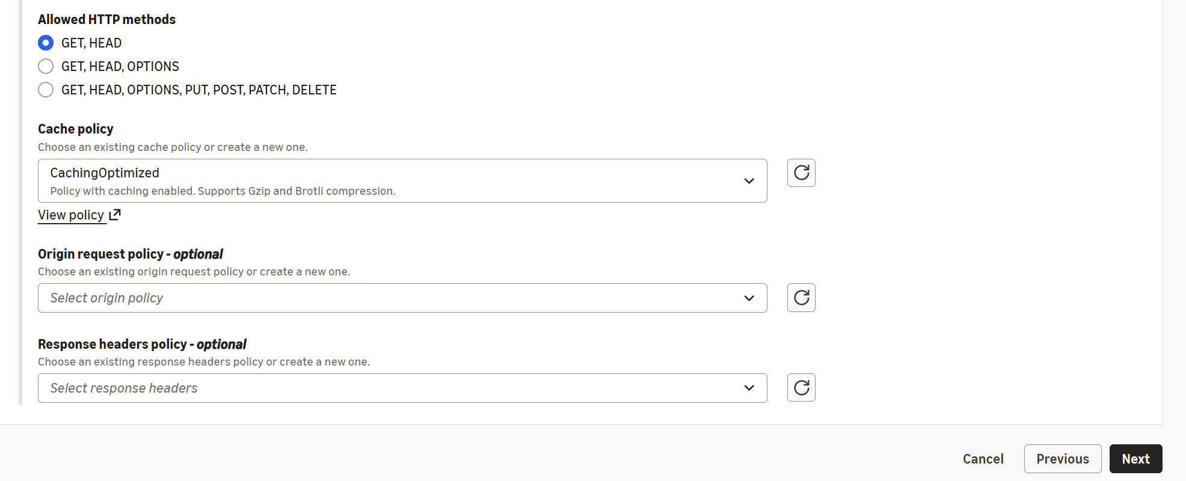
Click “Next”
Since the plan I have chosen includes this feature, I enabled it

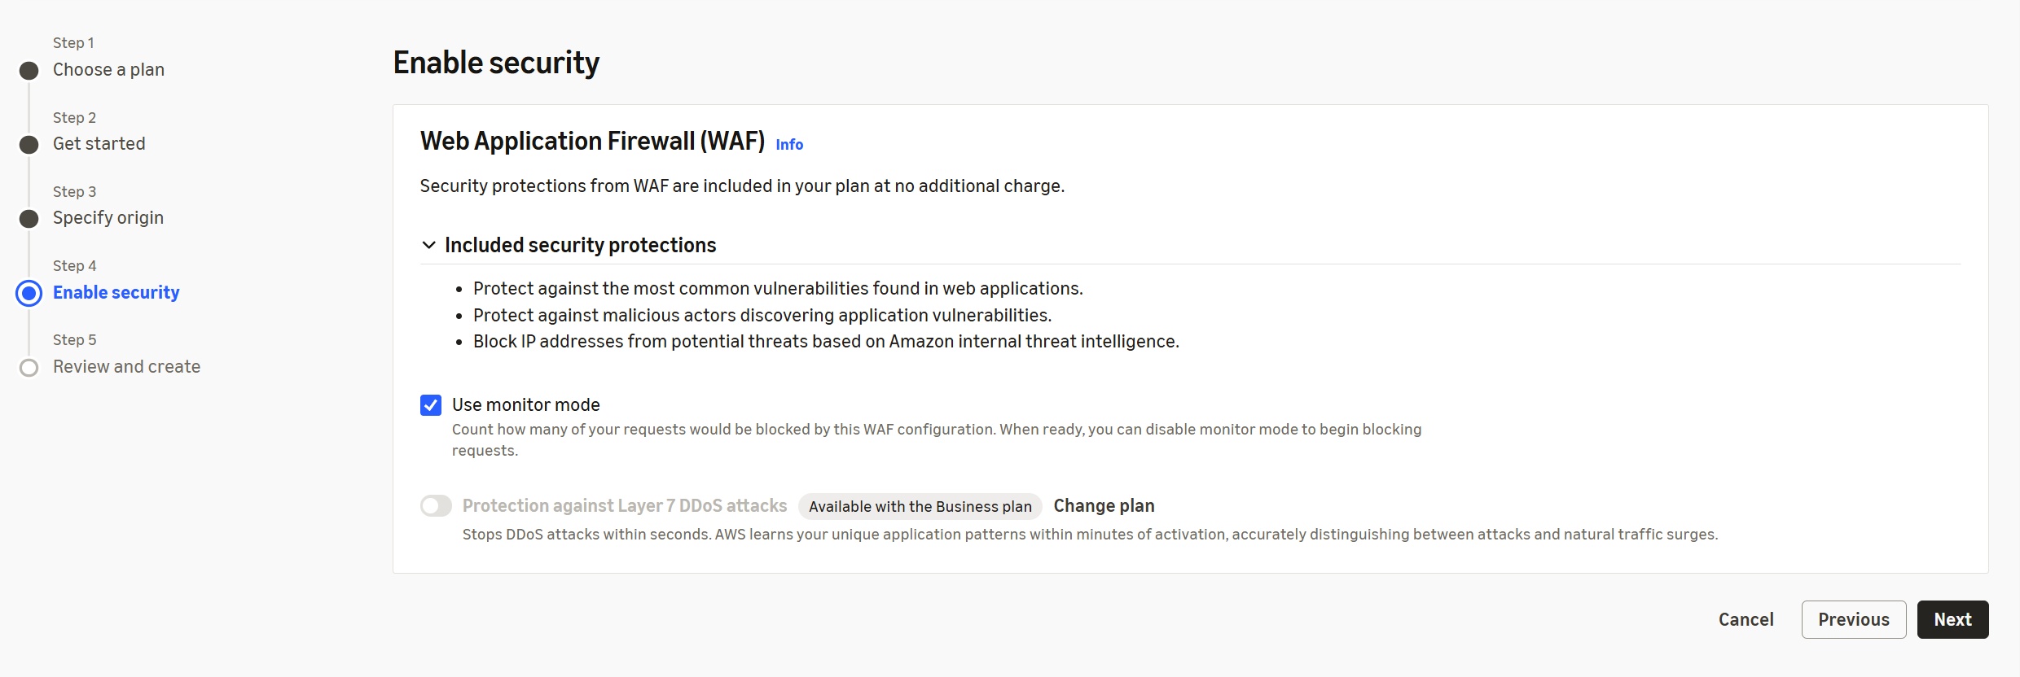

Click “Next” and click on “Create Distribution”

Request for a certificate in AWS Certificate Manager
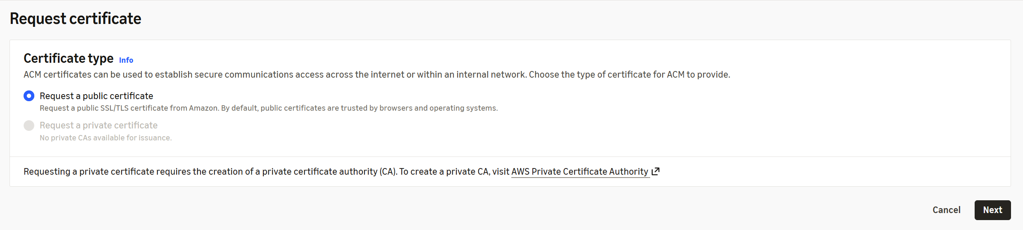

Click “Next”

In order for AWS Cloudfront to secure our static page, I have opted to use GoDaddy as my DNS provider, we need to add DNS records for us to request and create a certificate via AWS Certificate Manager(Free as of this writting). Please follow the steps mentioned below as each succeeding step is dependent on its previous step.
- Request a certificate in AWS Certificate Manager
Hit “Next”
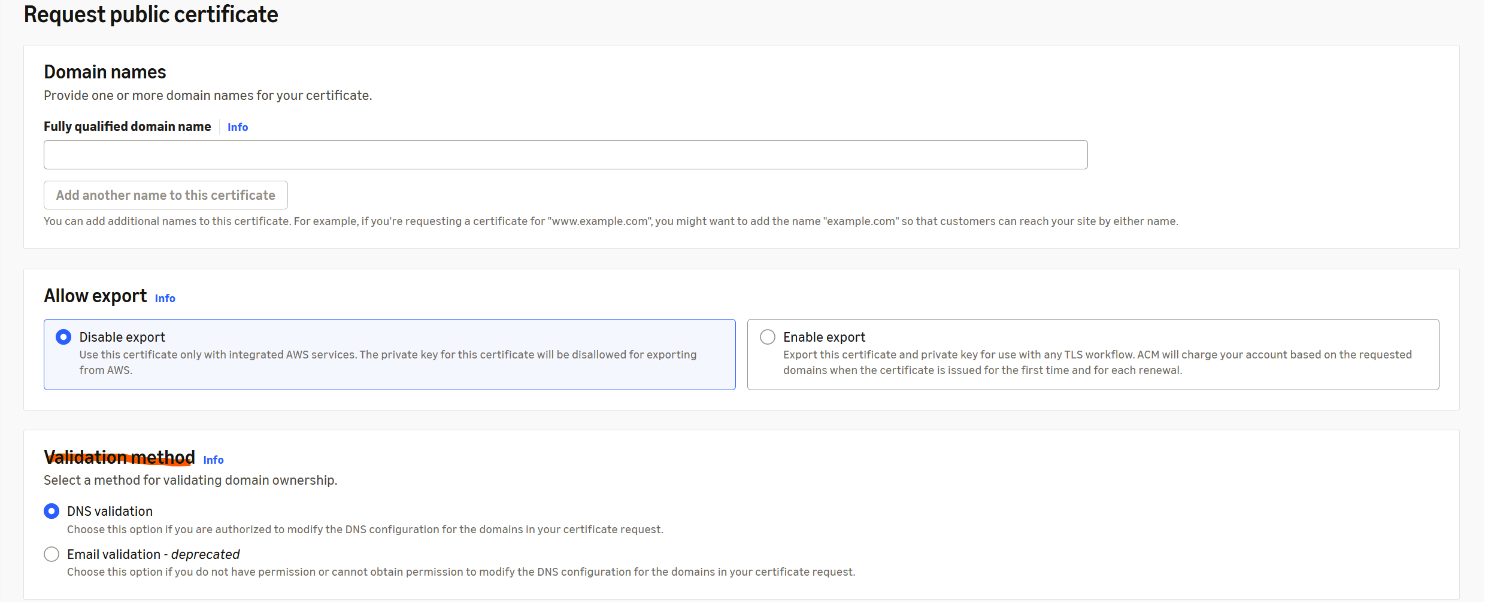
Click “Request”
At this stage the certificate is in pending validation
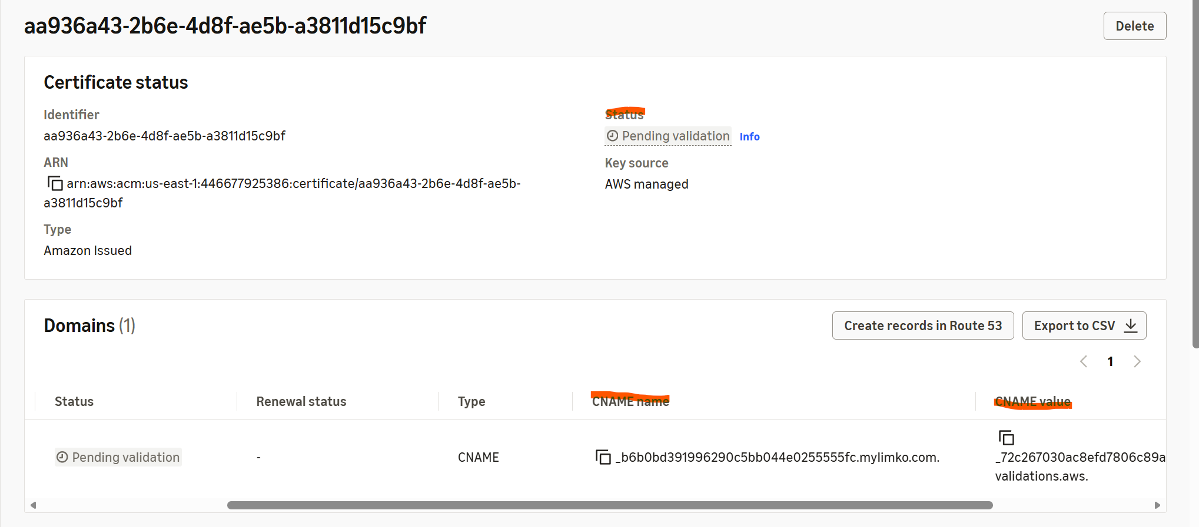
Pause here and perform step 2
- Configure DNS records, in GoDaddy
Create a CNAME record – copy the CNAME name and paste it as the name of the CNAME record and copy the CNAME value and paste it as value in the CNAME record and click “Save”. Do not forget to delete the . at the end everytime you copy/paste. Once it is propagated, the status of the certificate changes to “Issued”
- In order for GoDaddy to trust the Certificate Authority issuer (AWS Certificate Manager) as legit CA issuer, add the following CAA record:
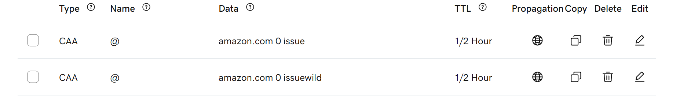
IMPORTANT NOTE: If you like to have a subdomain to obtain a personal touch like mine, I registered for mylimco.com, and wanted to view my cloud resume as cloudresume.mylimco.com. I needed to create another Cloudfront distribution for this purpose.

- Once the certificate is “Issued”, go back to Cloudfront under “General” tab and click “Add domain”. Define the domain you have just created and hit “Next”
- Choose the certificate you have just requested and hit “Next”
- Review the changes made and hit “Add domains”
- Go back to your newly created Cloudfront distribution and hit “Route domains to Cloudfront” Hit “OK”. Ignore the dialog box that you need to add an A and AAAA record. Instead add the following CNAME
This may have implications yet to be discovered and have not seen any issues so far yet.
- Check and verify if you can view your static website(index.html) using the AWS Cloudfront “Distribution domain name” by copy and paste in a browser.
- Check and verify if you can view your static website(index.html) using the CNAME you have just defined on step 7 above(www.cloudresume.mylimco.com)
Configure Lamda Stateless Function for website view count
Serverless, event-driven compute service where you run code without provisioning or managing servers. A key design principle of Lambda is that functions must be stateless.
Stateless means that each function invocation is independent — it does not retain data or execution context from previous runs. This design allows Lambda to rapidly scale by launching multiple instances of your function in parallel to handle incoming events. Any state that needs to persist between invocations must be stored externally, such as in Amazon S3, Amazon DynamoDB, or other databases.
Why Statelessness Matters
- Scalability: Lambda can instantly spin up thousands of concurrent executions without worrying about shared state conflicts.
- Reliability: Each execution runs in an isolated environment, reducing the risk of cross-invocation interference.
- Performance: Stateless design supports AWS Lambda’s ability to handle unpredictable traffic spikes efficiently.

First create an AWS DynamoDB Table
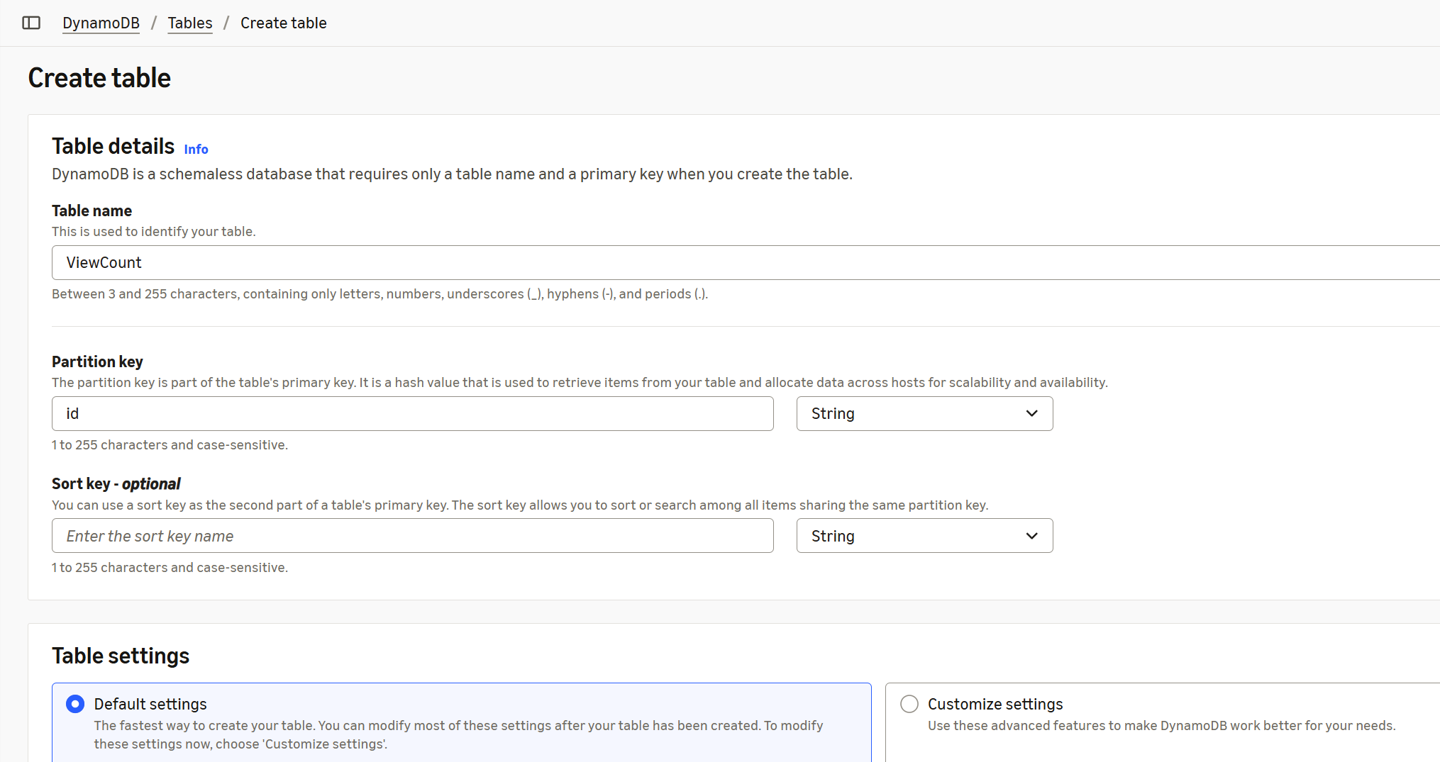

Define a Table Name and Partition Key
Hit “Create table”
Select the new table created and add table attributes by clicking “Explore table items”
Define value for id as “views” and “Add new attribute” “count” as Attribute name and 0 as value
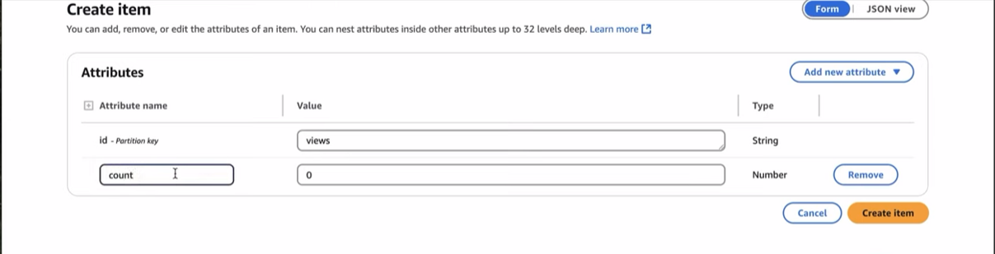

Hit “Create item”

Next, in AWS Console navigate to Lambda to create a function. Click “Create Event Function”
Assign a Function Name and choose a “Runtime” In my case I chose Python 3.13
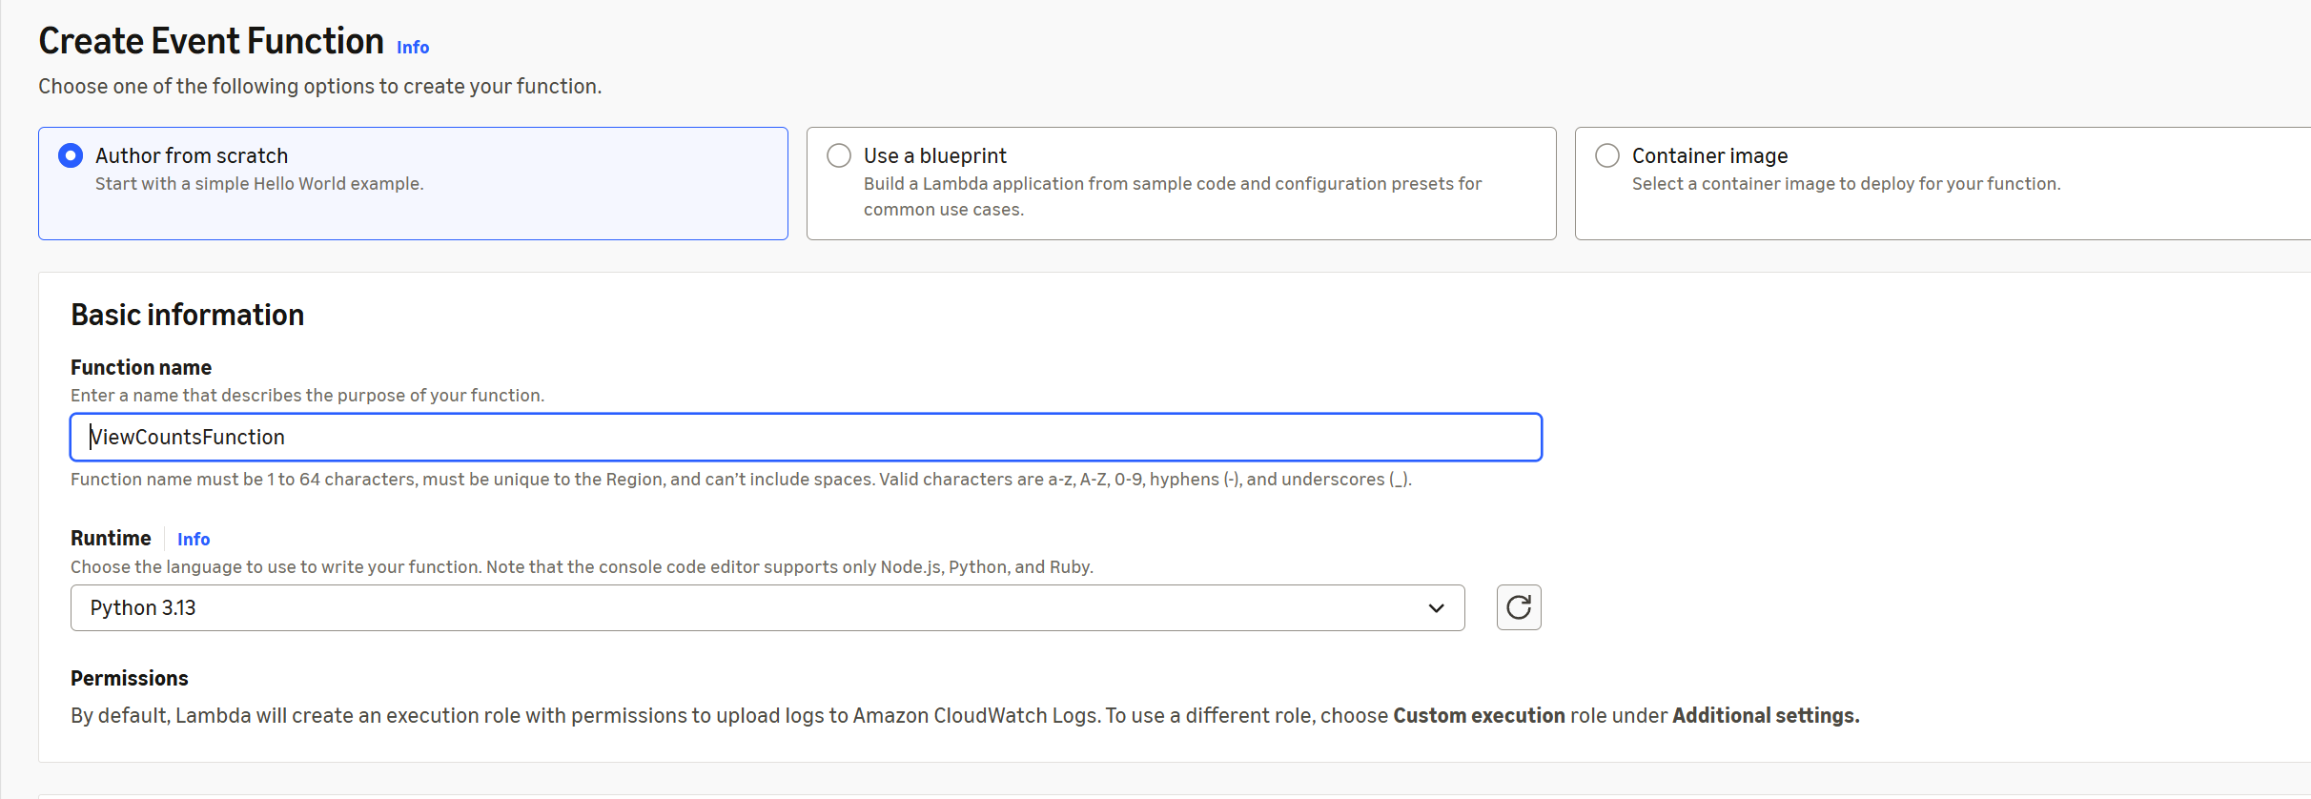

Hit “Create Event Function”
Go to Code” tab and define the following Python Code(also uploaded to my Github Repository for better formatting – Lanbda Function Code)

Python

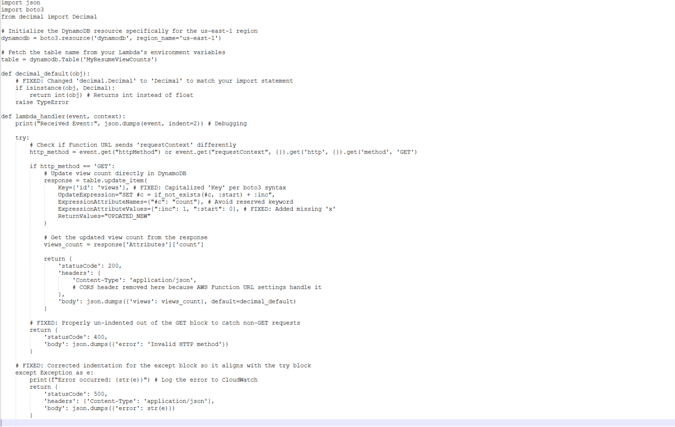
Make sure the AWS region is the same region where your AWS DynamoDB table

Click “Deploy”
Next we need to assign the IAM role to the Lamda Function just created for it to be able to write into AWS DynamoDB

In IAM console, look for “Roles” in the left hand corner of the page and select the Role created by the Lambda Function. By default there will be a policy name already assigned.
Click on “Add permission” select “Attach Policies”. Look for
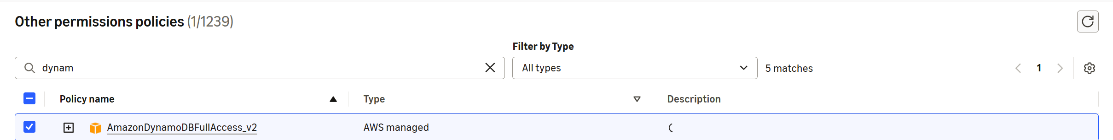
Hit “Add permissions”
Now you will see 2 permissions set
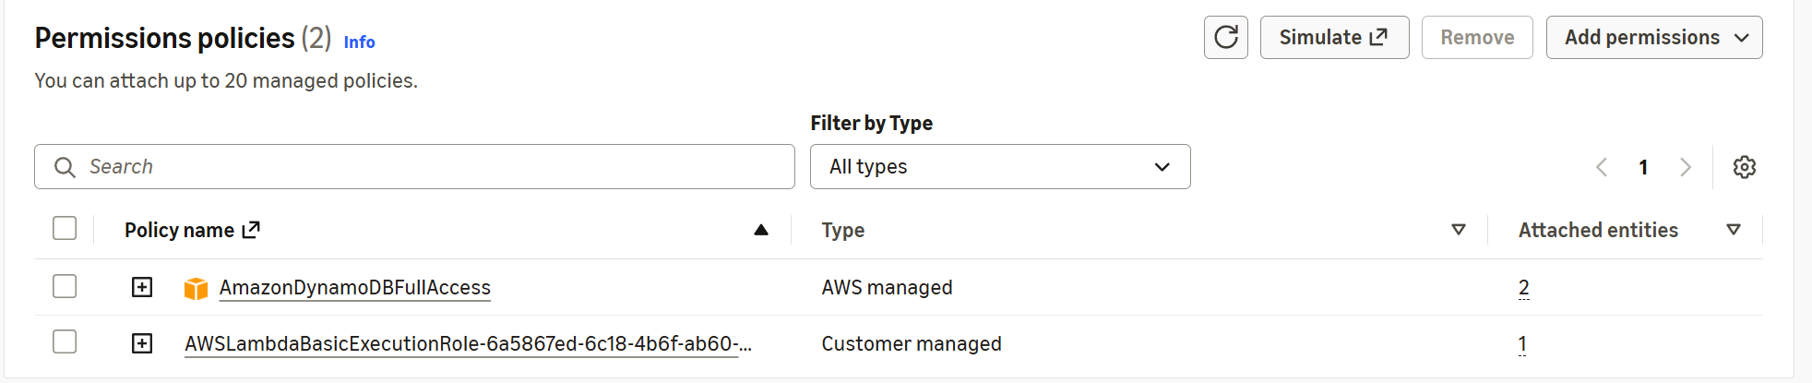

Go back to your Lambda Function and under “Test” tab accept all defaults defined but replace this section
From
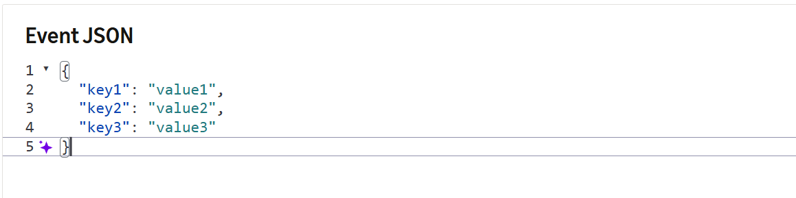
To
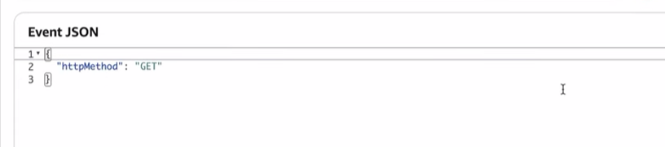
Run the test by hitting the “Test” button

To know if your Lamda function works, you should see the following
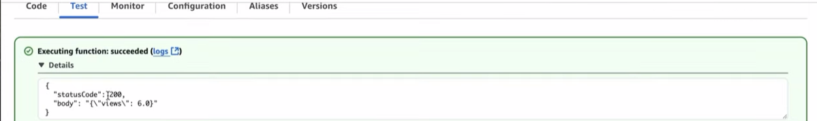
NOTE: The number increases by 1 every time you hit the “Test” button

Next we will use Function URL to be able to access this data from the external users point of view also known as accessing the data in the frontend

Go to your Lambda Function, look for Function URL in the left pane of the page under the “Configuration” tab, hit “Create function URL”

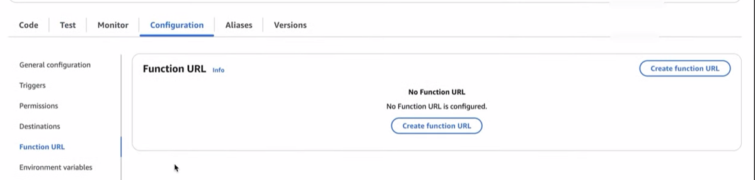
Choose “NONE” the “View policy statement” entries will be automatically populated. Hit “Save”. Go back to Lambda Console and select your newly created event function and you will see a section there to your Function URL. Click on that link and it will open a new tab which will show you the number of views.
NOTE: Every time you click on that link the value will increment by 1

Other ways to test is using Postman

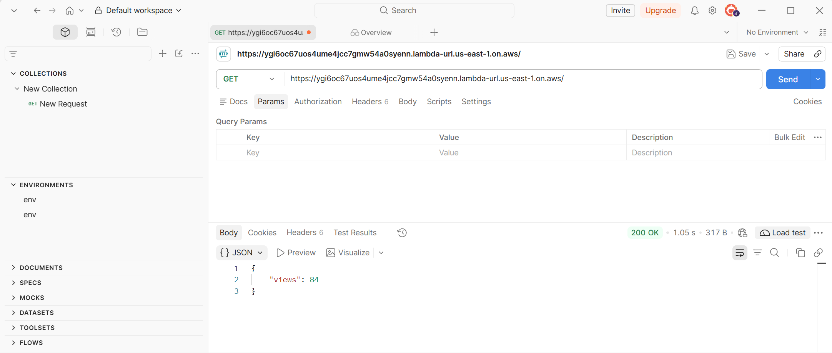

Next step is to configure our frontend access to indicate the number of views by adding a script in our index.html file with the following lines after the footer and before the body tag (also uploaded to my Github Repository for better formatting – Script for Views Count)

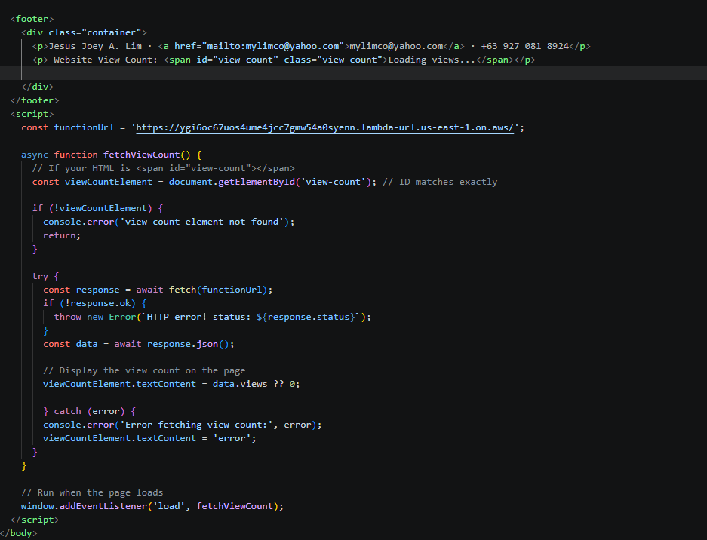

IMPORTANT! Make sure to re-upload your index.html to your S3 bucket. If you do not see the views count go back to your Lambda Function URL and make sure that the box is checked for Configure cross-origin resource sharing (CORS)

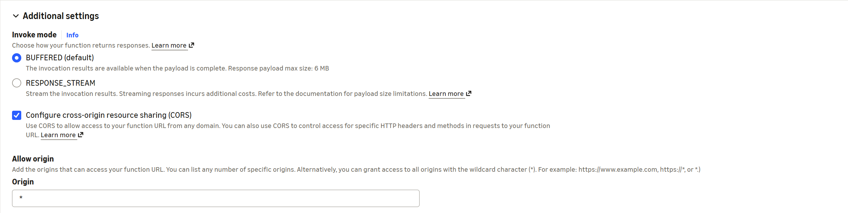
And set “Allow methods” to “GET”
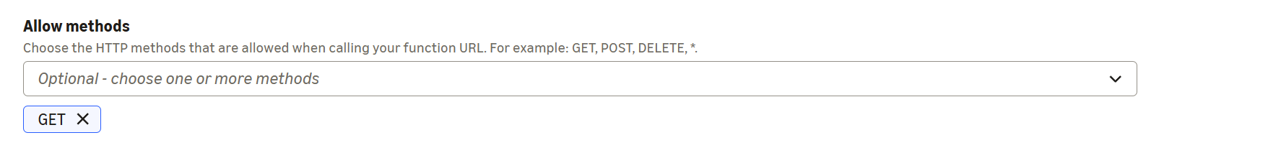
Do not forget to “Save” your changes

My Cloud resume Challenge is configured to have a custom URL using AWS Cloudfront. In order for me to achieve that, here is what I did.

Go to AWS Cloudfront. At the left pane look for “Origin Access” under “Security”. In the “Identities(legacy)” tab hit “Create origin access identity” and give it a descriptive name and “Create” Copy the ID name which you have just created and paste it in the line shown below and add these lines on the s3 bucket policy:

{
"Sid": "2",
"Effect": "Allow",
"Principal": {
"AWS": "arn:aws:iam::cloudfront:user/CloudFront Origin Access Identity <ID from Origin Access Identity>"
},
"Action": "s3:GetObject",
"Resource": "arn:aws:s3:::<s3 Bucket name>/*"
}
]

Do not forget to save your changes!

This time we are ready to view our static page (index.html) via frontend. Point your browser on the CNAME you defined on your DNS records. As for my case – www.cloudresume.mylimco.com

End of Documentation

I am currently working on another project to build everything using Code(Terraform, Python). Once completed, will be posted soon.
Stay tuned.

